Resisting Time – Memorials in Natural Landscapes
Natasha Doyon

Memorials are sacred sites that hold space for reflection and contemplation – they entreaty you to pause within a soundscape of muzzled screams and thunderous silences. I will be reflecting on memorials that coexist with nature. Where do they begin and end, and what is the right amount of buffer between them and modern life? Memorials that exist in natural surroundings have permeable gates and questionable buffer zones. Akin to memory and the past, there is no hard line that separates memorials in natural landscapes from their surroundings. It is messy and biological. The challenge of preserving memory in rural settings is to resist both natural and human progress. I walked around wondering what would happen if they were overgrown and forgotten, to simply become digital artifacts in cyber archives. Due to the precarious nature of these spaces, they are all the more expectant to be protected.

Logging Roads and Birdsong – Zbylitowska Góra
We had circled the town of Zbylitowska Góra numerous times looking for the entrance to the Buczyna Forest. It is easy to miss. Our bus drove into a shaded area, a canopy of deep-rooted Beech trees sheltered us from the afternoon sun. The earth was dark and well trodden on. The pathway slightly slopped towards a verdant forest, fresh with insects buzzing and birds singing. Their songs delineated a sound barrier between the village and us. There is a clearing and I can see fragments of dispersed memorials in the shadow of a Goliath concrete obelisk that is pointing upwards towards the blue ether.
Cement. Metal. Territory. The obelisk is a Communist effort at memorializing while maximizing its own ideological presence. I was curious about the gigantic sword embedded in the monument pointing downwards, and troubled by the generalizable way they honored the victims. Despite its overbearing presence, I recognized that they did not destroy the killing field and mass graves by pouring cement over the entire site. In the background, the Jewish and Catholic memorials are sunken into the earth, surrounded by bushes and trees that are slowly growing over them. All enshrined by a catatonic silence. The horror of this memorial is amplified by the solitude and absence of any human trace.

What thrives is a disobedient forest, rich with lush greenery, logging roads and hiking trails. This memorial is fragile because the earth is in constant movement. It is ephemeral not unlike memory that transforms over time.

Rusted blue metal fences demarcate the mass graves of Jews, 6,000 women, men and children including 800 Jewish children from the orphanage, and 2,000 Christian Poles. The Jewish memorials have stones placed on matzevot (tombstones) and those that have fallen to the ground, yizkor (memorial) candles, and loosely hung Israeli flags tied to the fences. The Christian memorials have crosses and clusters of fresh and dried flowers tied in red and blue ribbons.

Fresh flowers… Some people must still remain if they are placing fresh flowers.
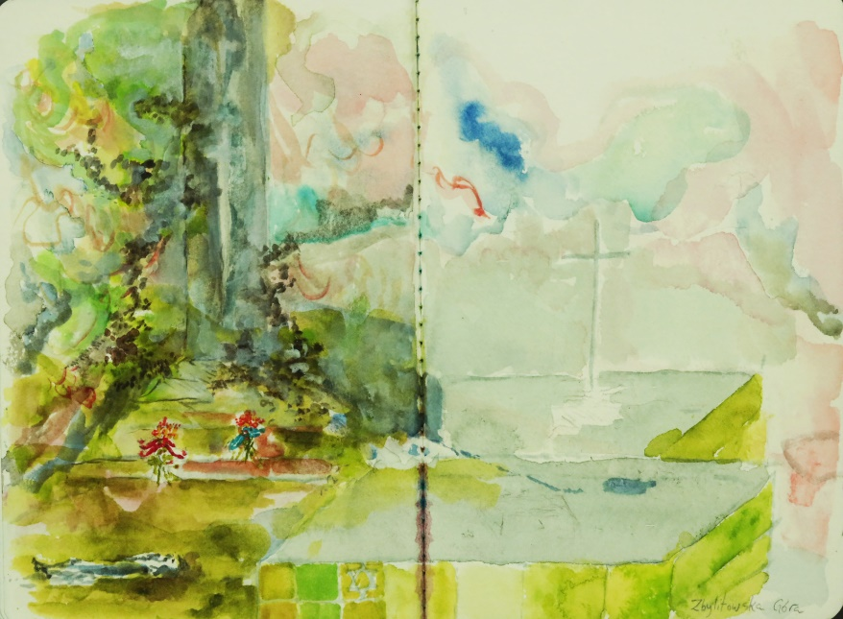

Zbylitowska Góra
Painting by Natasha Doyon
Watercolor on archival paper, 8x11 in, 2019
I carefully looked at where I was stepping in this emotional subterranean landscape – for this entire site is a resting place. The saplings contrasted the darker green depressions pitted in the earth. Disoriented by the weightlessness of innocent victims I needed to reorient myself. I wandered off down a path into the forest and took out my phone to record the sounds of the forest. Suddenly I saw a young boy wandering up the path. We were both stunned to see someone.

He looked scared and began to run off. I reassured him that it was ok – he ran back down the path towards a clearing. No more that 15 feet from the memorial is a logging road with numerous neatly piled wood stacks placed in rows. The young boy stood next to his bike and waited for his friend. This is their backyard, and a pleasant way to spend the day adventuring in the Buczyna Forest.

Treblinka II

Treblinka II is a sparse memorial enclosed in a pine forest. Its vast emptiness left me gasping for air. A sea of 17,000 matzevot, whose grey jagged tips flow into the forest. The earth is a spiritual archeological site empty of artifacts. An unbearable stillness of 900,000 lives lost comprising of their traditions, culture, stories, and familial lineages - evaporated.

An active sign of remembrance is the Ribbon of Remembrance. A white ribbon with the names and surnames of 4,000 people who were murdered in Treblinka II is woven throughout the trees in the forest. If all the names were written, the entire forest would be covered in white, because they only represent less than 0.5% of the victims at this site. I followed the ribbon, stepping on dry branches and soft mossy earth, swiping away the insects that come out in the rain. Embodying a still rage that swelled in my throat, tempered by the loving hands that placed this long ribbon. In the Jewish tradition, it says that we die two deaths, the first is our body and the second is when we are forgotten.

Scattered light purple wildflowers and grass push through the cracks in-between the stones, mirroring the restlessness of memories. Time lapses here, with one foot in the past and one marking my path through the stones I instinctually search for an echo, to hold onto something tangible. I hold onto silence and walk away more perplexed. What are the future challenges of remembrance in these sites that are conditionally ephemeral and vulnerable to the seasons? Not to mention the current whitewashing and rewriting of history, these sacred sites demand protection.
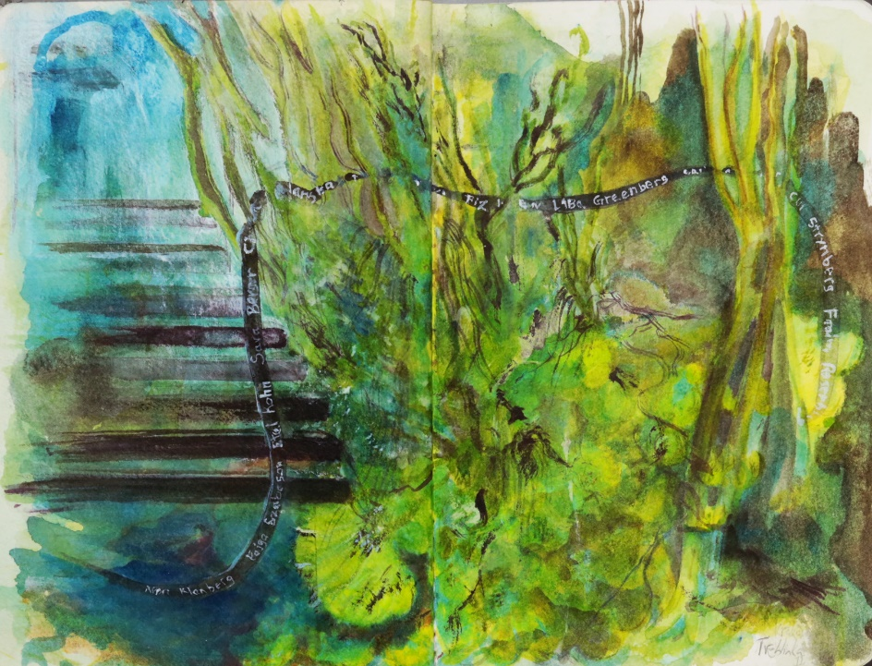

Ribbon of Remembrance – Treblinka II
Painting by Natasha Doyon
Watercolor on archival paper, 11x8 in, 2019

One of our Fellows asked, “What is the educational value of these sites?” and that question still lingers with me. It depends what one defines as educational, I will borrow from John Dewey, who believed that knowledge is based in real life experience. There are a multitude of ways to encounter a memorial, however, it is faulty to expect anything. It is a sorrowful warning.

As an artist one of the ways I processed these sacred sites was through painting, these watercolors were done on the bus or train throughout our Fellowship.

Natasha Doyon is a Ph.D. candidate in Art Education at Concordia University. Her research is at the intersection of arts education and social justice to counter radicalization in youth in Israel amidst the diverse population. Natasha is partnering with the Israel Museum’s Youth Wing to research peace education initiatives that have built bridges with Israeli-Arabs in spite of exclusionary ideologies, and the problematics of addressing central and peripheral belief systems of victim/oppressor, minority/majority and core identity beliefs systems. She is using a critical arts-based pedagogy to situate youth as key participants in developing and actualizing change within their communities. Natasha is an Israeli-Canadian professional artist and art educator who has won numerous awards, and exhibited nationally and internationally. She has a BFA from Concordia University and a MFA and B.Ed. from the University of Ottawa.

- John Dewey, Democracy and Education: An Introduction to the Philosophy of Education (New York: Free Press, 1966).

